COMBINATIONAL VISION

By
GM Bong Villamayor
Powerchess Asia

After learning the fundamentals of tactics and have gone thru the study of numerous tactical themes, we further stretch our ‘chess creativeness’ by exploring combinations played on the higher level.
The level of combinational vision is important if we wish to go to the upper echelons of chess tactics; the deeper you calculate and picture the positions the more your attention widens on the board.

1/W 2/W 3/W
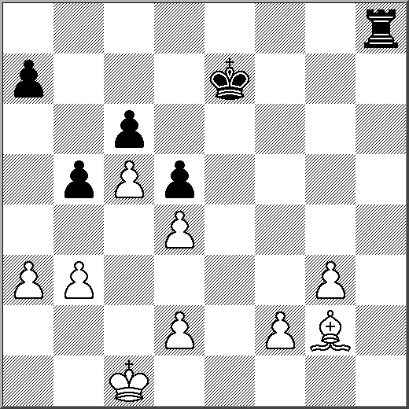
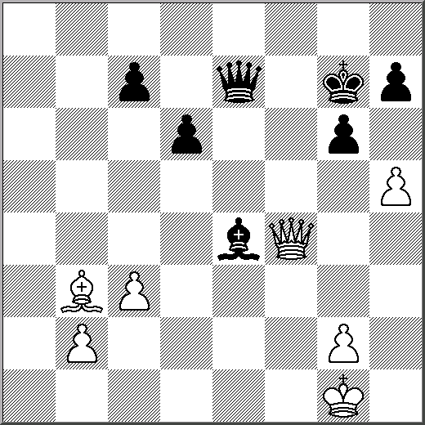
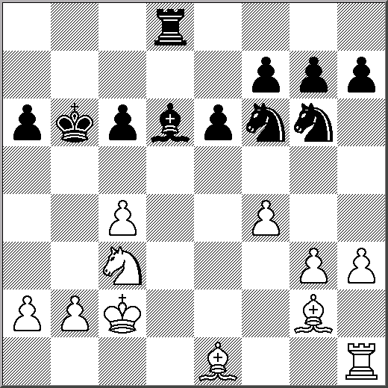

4/W 5/W 6/W
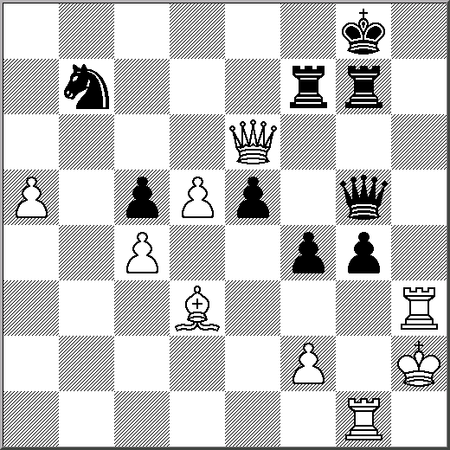
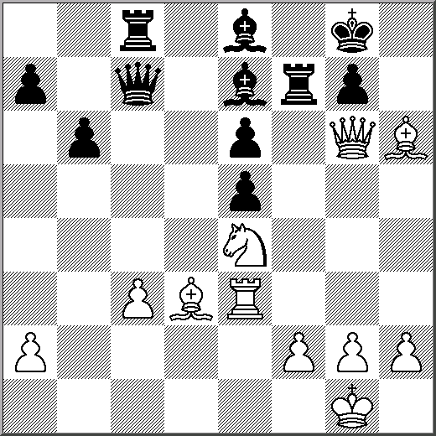
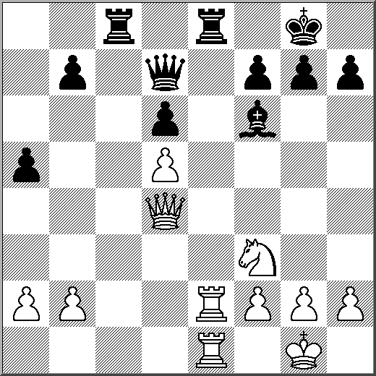

7/W 8/W 9/B
